Capstone Project Report


Team5
Brianna 221374806
Tyler 221882576
Kieran 221323167

Table of Contents
Table of Contents 2
Executive Summary 3
Key Learnings 4
Key Challenges and Issues 5
Recommendations 6
Appendix
Team Charter 7
Team Roles and Assignments 8
Baseline 9
Status Report 1 9
Status Report 2 9
Minutes 11
Feb 12 2025 11
Feb 19 2025 11
Feb 26 2025 11
Mar 05 2025 12
Mar 12 2025 12
Mar 19 2025 12
Retrospective 13

Executive Summary
This capstone project explored the critical role of communication in enhancing personal effectiveness and teamwork. The team focused on five key topics: conflict models, active listening, dismantling hierarchies, using proper language, and the value of feedback. One key insight was learning about the Thomas-Kilmann conflict model that provides different approaches to navigating conflict.

Through weekly meetings, collaborative efforts, and presentation rehearsals, Team 5 developed a solid presentation that emphasized modern, and research orientated strategies to discuss communications in the workplace. Team 5 incorporated relatable examples in their presentation to connect with their audience who were in early stages of their career. The final deliverable was a group presentation aimed at converting theory into practical workplace solutions.

Throughout Team 5’s process of creating the presentation, they found more collaborative and easy user interface software better for teamwork such as Google Slides. It was important to have a visual application to track roles and assigned tasks. Most importantly, buffering extra time during developing their presentation was key to challenges that include time management, balancing tasks, switching between various tools and unexpected delays.

One of the key takeaways and recommendations from this project was to make the presentation more engaging. Instead of a lecture based presentation, at the beginning of the presentation a pre-discussion with the audience should be held or before every subtopic. As a result, the participants will be able to provide their own perspectives and enhance their learning by connecting with the content.

Key Learnings
Through this presentation, we learned about the conflict model, active listening, dismantling hierarchies, language use and feedback culture.

Understanding the Thomas-Kilmann conflict model helped clarify that different conflict situations call for different strategies (e.g., avoiding, compromising, collaborating). When deciding on a conflict model to implement, there are various factors to consider such as personality traits of stakeholders, the problem itself, interpersonal relationships and hierarchical position. Additionally, comprehending the nature of conflict was important to understand how conflict can be avoided altogether.

Moreover, we discussed how to practice active listening where we highlighted the importance of empathy, non-judgmental presence, and reflection in creating trust and open dialogue. Active listening is a crucial skill to develop in your early career to build trust and rapport with your colleagues.

Exploring modern organizational structures emphasized the benefits of flattening power dynamics, which can foster creativity and employee engagement. Some of the strategies that could be applied to the workplace to dismantle hierarchies are having an open-door policy and rotating leadership roles.

Recognizing how precise, thoughtful language boosts understanding and retention was a practical insight into everyday communication. Most importantly, in our early stages of our career, using proper language is key to encouraging learning.

Finally, learning how to deliver and receive feedback constructively reinforced the idea that growth relies on clear, respectful communication. Feedback needs to be delivered in a clear and specific manner to maximize the impact.

In terms of our key learnings from our process of working as a team, we learned the importance of being adaptable and communicating in advance. Sometimes, we would have to move our meetings back due to work commitments or commuting from work. Therefore, it was crucial for us to communicate those changes in our group chat to let others know ahead of time. This led to our success in status report meetings where sometimes one of us would not be able to attend the meeting due to a meeting at work. As a result, the other members of the team were able to plan accordingly to share our status towards completing the presentation by the deadline.

Key Challenges and Issues
Key challenges and issues we faced when preparing for the presentation were time management, transitioning between different tools, balancing tasks and polishing our content. Coordinating schedules and meeting deadlines was difficult, especially when team members needed extensions. Initially, we were thinking of using LaTeX for our slideshow because this project would be a great opportunity to learn this new tool, for those who have not used it. However, ultimately we decided to switch from LaTeX to Google Slides because of its easy to use interface which delayed progress slightly but improved collaboration. Managing the workload across multiple course obligations sometimes affected our team focus and delivery. Especially with our program where we are in a work integrated program, some weeks at work were more demanding than others which affected how we balanced our tasks. Refining the slides and ensuring all sections aligned stylistically and substantively required multiple meetings and reviews.

Recommendations
For the group
For the group, we would recommend starting the project early, assigning roles clearly, using shared collaboration platforms, scheduling buffer time and formalising a reflection after the presentation. Beginning group projects earlier will allow for unexpected changes in availability and technical preferences. For example, our team had to change our slideshow software and was able to do so because of starting the project early. Early role assignments can streamline slide development and minimise overlap. Therefore, having a visual project board to track roles and tasks is important. Tools like Google Slides and GitHub are ideal for collaboration and should be prioritized for group projects. In addition, including extra time in your plan for revisions, rehearsals, and unexpected delays should be considered. Finally, allocating time post-presentation to reflect as a group on challenges, learning, and improvements will enhance the collaboration for future teamwork.

For the class
For the class, we would encourage more discussions for the presentation. Shifting the format from a primarily lecture-based approach (feels like 90-10) to a more balanced mix (around 50-50) would enhance engagement and make the sessions more enjoyable and interactive for everyone. Discussions promote deeper understanding and allow for more diverse perspectives to emerge.

If we were to do this project again, we would apply this recommendation to our presentation. We included examples to help the audience engage more with our content. However, we found that having a pre-discussion before diving into the topics of communications would be helpful to connect more with the audience.

Appendix

Team Charter
Why we exist: DIGT 1161 Capstone Project
Team members: Brianna, Kieran and Tyler
Stakeholders: Kai and Larry

Team Goals
Through this project, our main objective is to learn and strengthen our communication and teamwork skills. We want to be more efficient in using collaborative tools such as GitHub and want to gain a positive experience from working with each other. By the end of the project, we want to feel accomplished of how we worked together and be comfortable working with one another in a future project.

Values and Principles
- Commitment: we will set realistic goals and milestones to achieving our goals.
- Communication: we will communicate about any changes or blockers towards completing our tasks. We will have clear communication, transparency, be willing to work together, negotiable and punctual. If there are issues within the team, the team member will share it with other team members immediately.
- Adaptability: we will be open to new ideas and changes to project topics, meeting dates, etc.
- Respect: we will respect each other's ideas and opinions.
- Integrity: we will be open and honest about new ideas, opinions and feedback to improve our project/teamwork.
- Trust: we will assume positive intent from all team members.

Team Practices
- We will have weekly meetings on Wednesdays at 6:00 PM, through Discord and meeting minutes will be shared through the Google Docs.
- We will communicate through Discord in our group chat.
- Team members are expected to respond within a day but we understand that it may take longer. If an immediate response is required from a team member, they will mention them in the group chat which will notify them.
- All team documents will be shared in our Google Drive folder.
- Tasks and role assignments will be indicated in our GitHub project board.

Team Roles and Assignments
We did not assign a project manager for our project since this was a relatively small assignment and we found that assigning a project manager would be unnecessary. Therefore, we used this GitHub project board to assign tasks and ensure that we all stay accountable for our work.

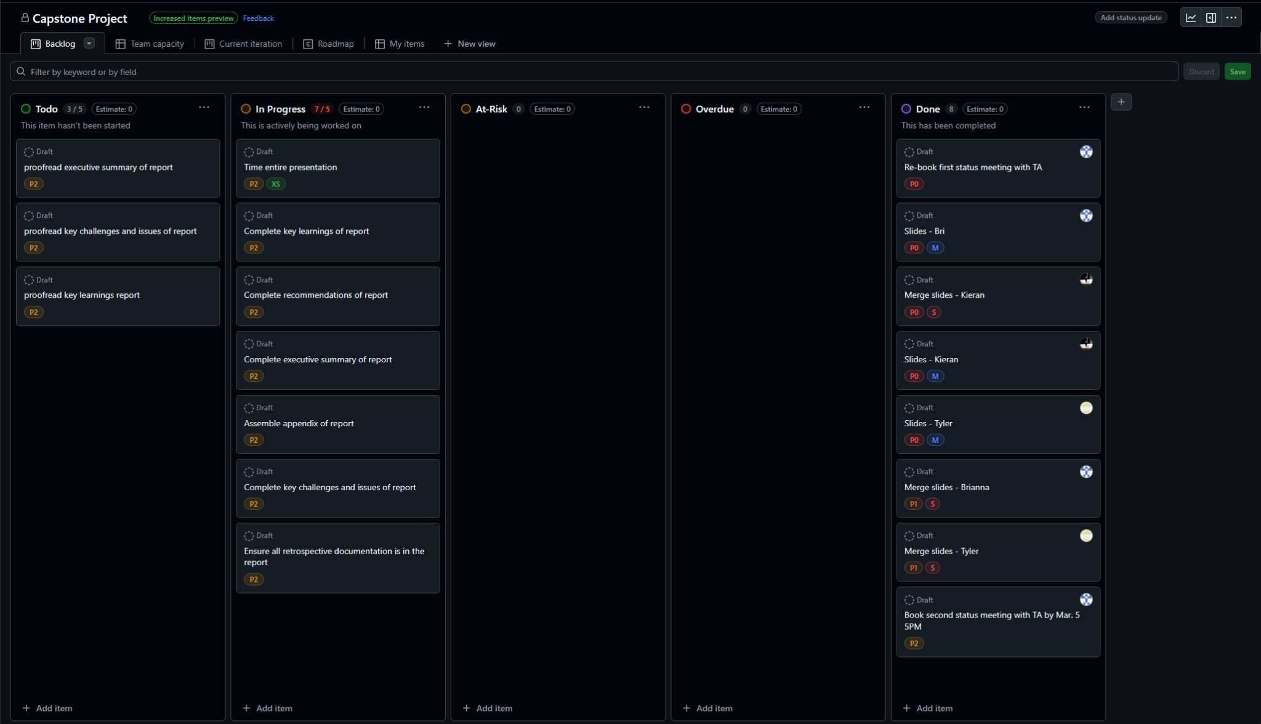

Baseline
Initially, every person picked 2 to 4 topics, with 2 to 3 slides each per topic and aimed for 3 minutes total per person. However, in our final presentation, this was modified to account for time and stylistic purposes (having more slides with less text to make it more engaging for the audience).

Kieran | Tyler | Brianna
- Value of feedback  - Using proper language | - Active listening  - Dismantling hierarchies | - 3 stages of conflict  - 3 models of communication

Status Report 1
Status report went well, we talked about our slide progress and what we would need to add to our presentation. We showed the TA our Github Project and meeting minutes to demonstrate how we were tracking efforts. At this point, we simply needed to merge our slides, however, all research and topics have been completed. We had little to no feedback since everything was on track and we were expecting to meet the presentation deadline.

Status Report 2
Similar to the first status report, we presented our Github Project board and meeting minutes to explain our progress. Minor feedback was that our team charter was a little messy, so we polished and simplified it. Rest of the feedback was all positive, we are 100% on track with no blockers or delays because now we were reviewing our slides and practicing our presentation.

Below was our previous team charter that we presented in our status report meeting.

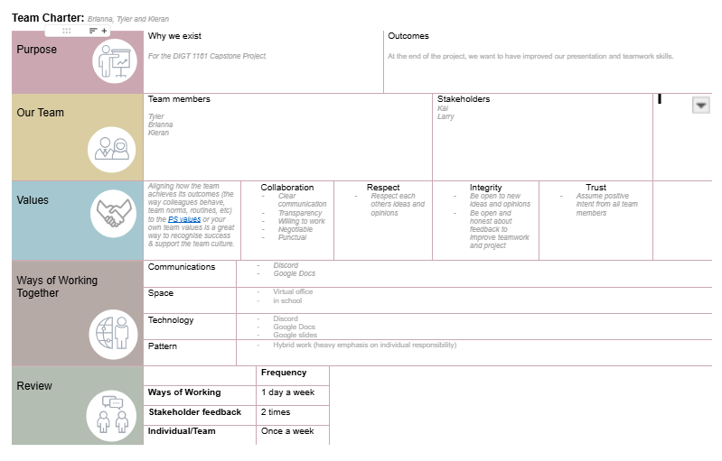

Minutes

Feb 12 2025
- 19th, 21st for standup
- Pick 2~4 topics, 2 slides each per topic, aim for 3 minutes total per person

Kieran | Tyler | Brianna
- Value of feedback  - Using proper language | - Active listening  - Dismantling hierarchies | - 3 stages of conflict  - 3 models of communication

GOALS:
- Finish our slides + presentations by 2025-Feb-19th
- Book second meeting with TA and cc Barnaby through Google Meets
  - DIGT - March 17 or March 19

Feb 19 2025
Last week's goals: 50% met
Plan:
- We are doing our second status meeting with the TA on March 17 from 10:30 - 11:00 AM
- We are extending the timeline for Kieran and Brianna because they need more time to complete the presentation
- We are switching to Google Slides instead of LateX because the interface is easier to use
- Next meeting: Feb 26, 6pm

GOAL: Finish our slides + presentations by 2025-Feb-19th 2025-Feb-26th

Feb 26 2025
Last week’s goals:100% met
Plan:
- Debrief Status Meeting with TA - went well, need to polish team charter
- Next meeting: Mar 5, 5pm
  - Will go over slides to see if we need to add/omit information
  - Discuss next steps for report

GOAL: Merge slides together Capstone Project: Team 5 by March 5, 2025

Mar 05 2025
Last week’s goals:100% met
Plan:
- Brianna add citations
- Speech ready!
- Everyone write their lessons learned/challenges
- Jot down ideas for report (exec summary, lessons learned, recommendations and appendix)

GOAL: Write speech, but no need to prepare for the presentation

Next meeting: Wednesday Mar 12 at 6 PM

Mar 12 2025
Last week’s goals:100% met
Plan:
- First run-through of presentation
- Is there a format for the citations (MLA or APA)?
- Status Meeting this upcoming Monday

GOAL: Review slides for content and timing (should be around 3 minutes)

Next meeting: Wednesday Mar 19 at 6 PM

Mar 19 2025
Last week’s goals:100% met
Plan:
- Run-through of presentation
- Final meeting unless disaster occurs, well done team \o/

GOAL: Ensure that everyone’s speech is under time.

Retrospective Documentation
Overall, our project was a success! We effectively planned our progress towards completing the project. We documented all of our tasks through GitHub which was helpful because we could set deadlines, assign tasks and add effort levels to each task. We each picked one to two topics each, and agreed on 3 minutes of presentation time each. This was an effective way to plan our presentation because we were able to touch on different subtopics of a broad topic but we stayed within the time limit. We set up weekly scrum meetings, and worked collaboratively in an agile manner. We used our status meetings with the TA to check our relative progress, and we were either on track or ahead of the curve. This was a great opportunity to also get outside feedback on our presentation and ask questions. We had several dry runs, and improved our presentation iteratively. In particular, our in-person dry run was the most effective because we practiced the rotation for clicking each slide. We had continuous retrospectives during our weekly meetings, and since we had no clearly defined roles, we all did what had to be done responsibly. All documents were stored in our Google Drive folder which made it easy to find documentations for the project.

In the future, we could incorporate more questions to ask the audience to make the presentation more interactive. We were under the impression that we could use the Q&A session as an opportunity to ask questions to the audience and engage with them. However, we misunderstood this portion of the presentation. Therefore, it’s important to ask more clarifying questions before starting the presentation.

